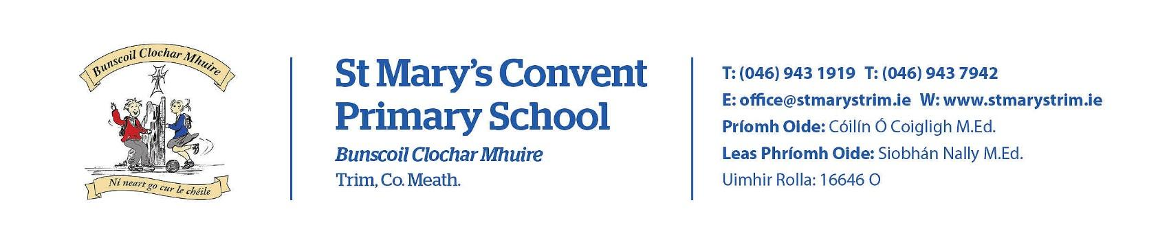
Imlitir 3

11th September 2023
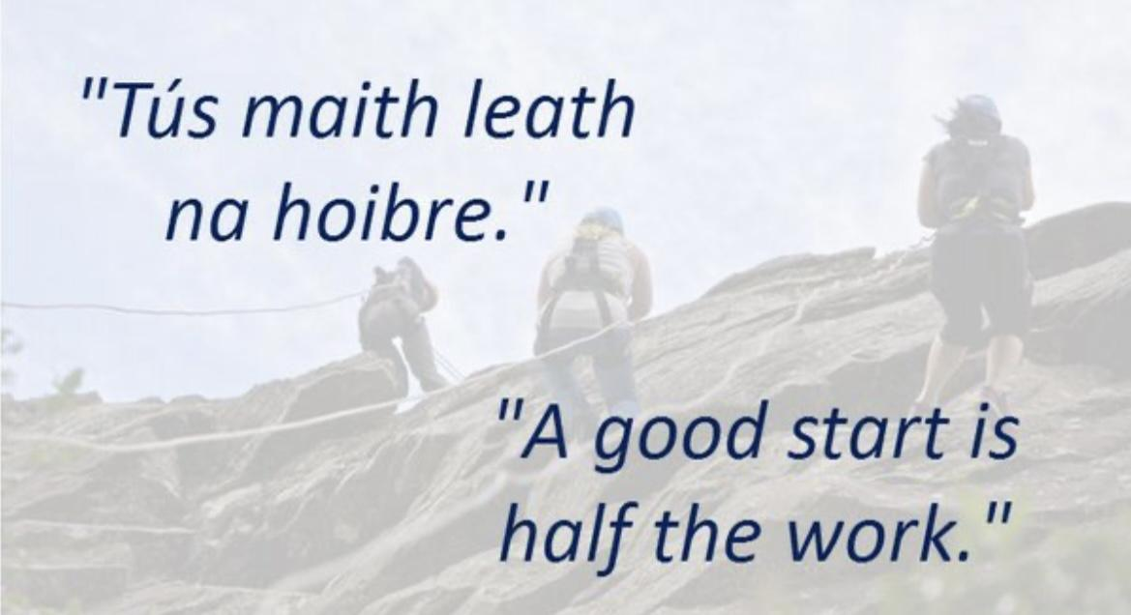

A Chairde,

Please note that the Junior Infants finish at 1.50 from today on. First Classes finish at 2.50.

School photographs will be taken on Friday September 22nd. Further details will be sent closer to the time.

Swimming
Swimming begins this Thursday 14th Sept for 2nd - 6th classes. The lessons (Aquatics) are part of the PE programme and will run for 6 weeks. The cost is €32 for the six lessons and is payable online. A letter was sent last week with further details. For child protection purposes, parents/guardians may not enter the changing village but can assist their child with dressing if need be, by taking them into the separate changing area.
Ms O’Brien
Homework Club
St Mary’s Primary School will run a Homework Club this year in room 26, beginning on Monday 11th September. It will be aimed at children from 1st-6th class. It will be run by qualified teachers on Mondays, Tuesdays and Thursdays of each week from 2:50-3:50 pm. The children can be collected at the exit door nearest the Summerhill gate each afternoon.
The homework club will:
• Provide a supervised environment in which students can spend time at their homework.
• Students are encouraged to bring a light snack and drink. Time will be allocated for students to relax and eat/drink prior to starting their homework.
• Students will be encouraged and supported to do their homework to the best of their ability.
• The teacher will check spellings and tables with all children.
• Students that finish their homework early can engage in activities such as reading, art, playdough and puzzles.
• The final responsibility for checking the homework and reading rests with the parents.
Please see attached booking form with more details.
Ms Carr

Backpack Programme: This is a wellbeing programme for adults. It starts on September 20th and runs for 10 weeks. Please contact the office if you would like a brochure with more details.
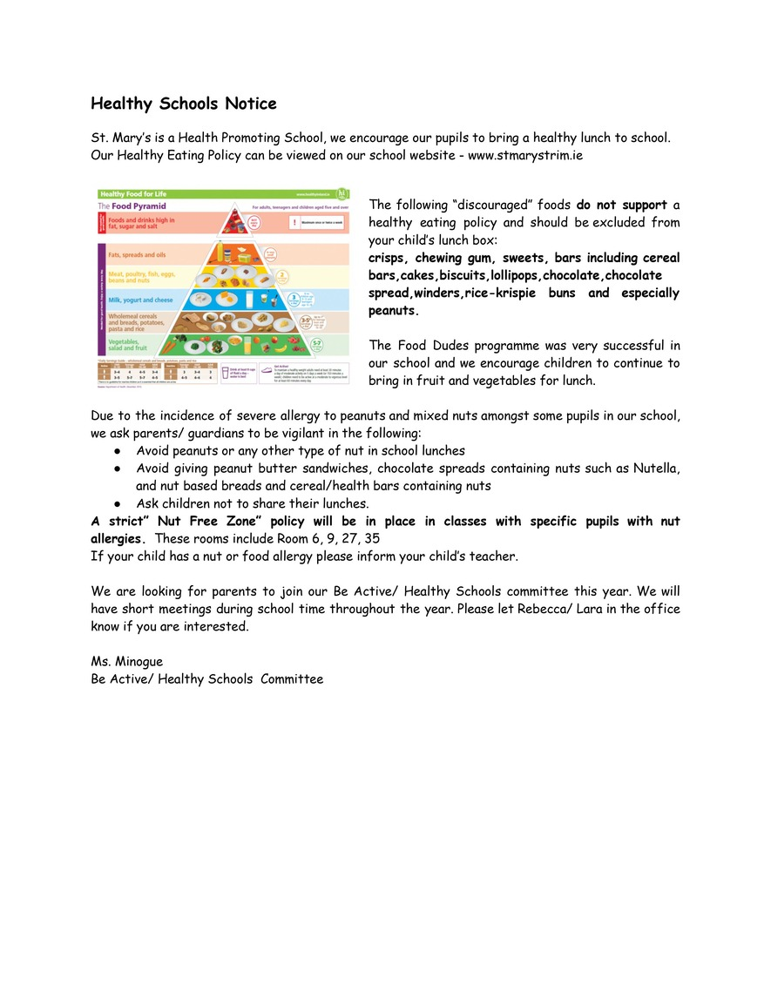
As Ms Minogue has mentioned, we are looking for volunteers for the following committees:
- Gaelbhratach
- Digital Schools
- Be Active
- Healthy Schools
- Green Flag
The committees are made up of staff, pupils and parents/guardians. We have short monthly meetings. These committees are more effective if all sections of our school community are involved. If you are in a position to join or if you require further information, please contact the office.

D.T News: This week students in 1st class will receive their Google logins. They will then learn how to login in with their passwords and navigate to Google Docs where they will begin to learn the letters on the keyboard and will type sentences with these newly learnt letters. Students from 2nd to 5th classes will learn how to create a CV. The 6th class will begin work on their Stop Motion projects. These projects will be in conjunction with what they are learning in class.
Debby Walsh

Finally, Cathy Brennan comes to the end of her placement with us on Friday. In the past year and a half, she assisted us with the Library as well as the Guided Reading Library and did phenomenal work in both areas. It was very laborious but she did it to a very high standard and always with a smile on her face. Thank you Cathy. We will miss you.

Mise le meas

Cóilín Ó Coigligh P.O.

Green News
Community News

Nathanna na Seachtaine: Go raibh a maith agat! (Thank you)
Seanfhocal na Míosa: Tús maith, leath na hoibre (A good start is half the battle)

Green News

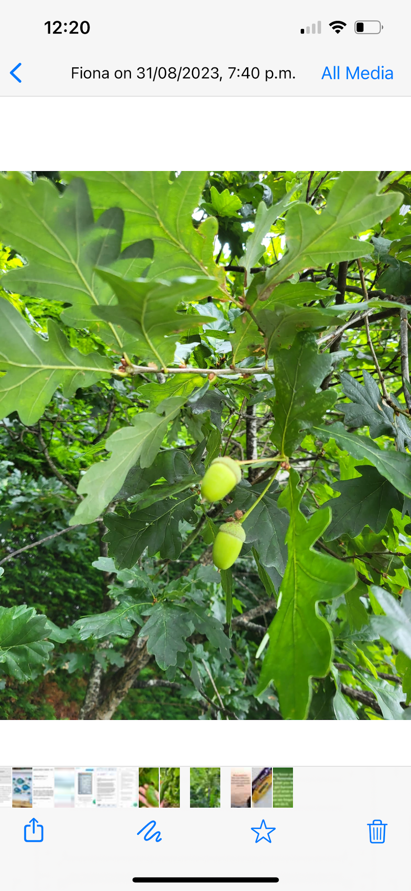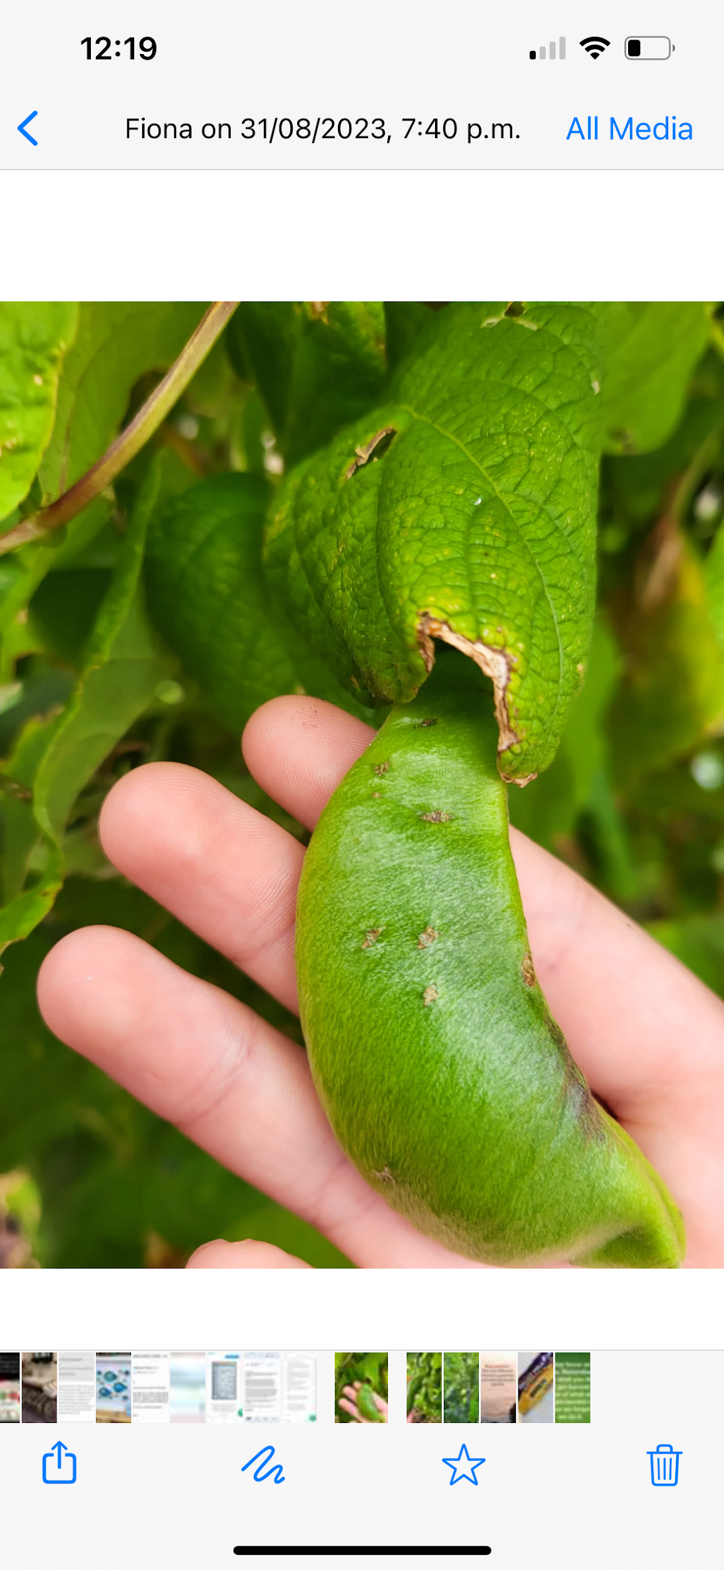
Lots of lovely greenery to be seen around the school

Spend some time looking around at nature this month and notice such things as blackberries, chestnuts and acorns.

We can try to recycle and reuse materials through our recycling centres or by being creative about how we can reuse items ourselves.

Two pupils set up a shop last week in their estate and used a variety of recycled items. Maith sibh a chailíní!

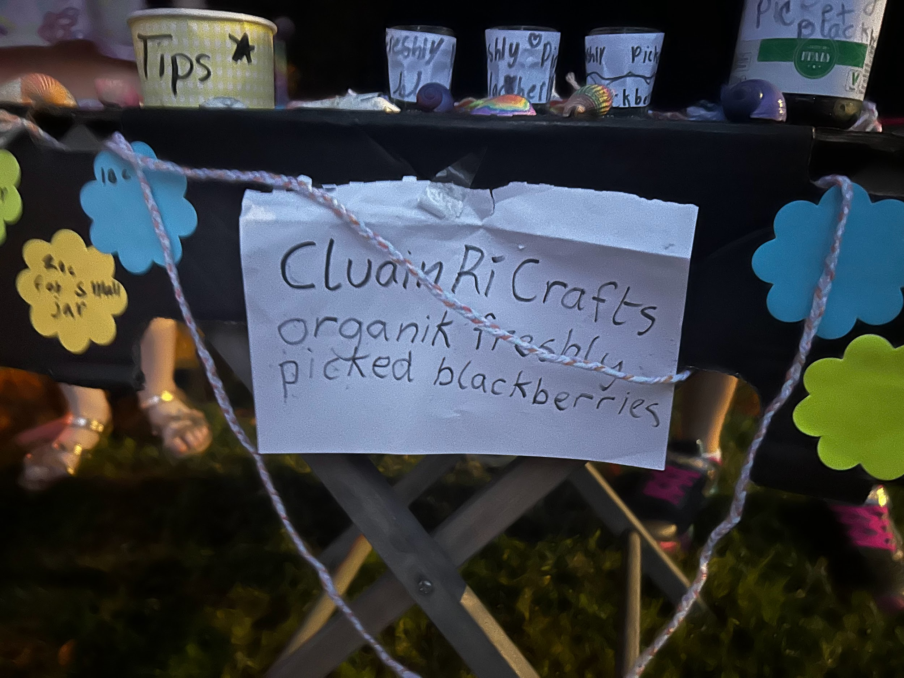
Our Green Flag theme is Global Citizenship - Travel. We can walk and cycle more to reduce carbon emissions and keep our air clean. WOW will start on Wednesday, September 13th Meet up at Gullivers at 8:50 am.

COW will start next week September 20th. More details about this later. We have a lovely new Bike shed so let’s put it to good use!
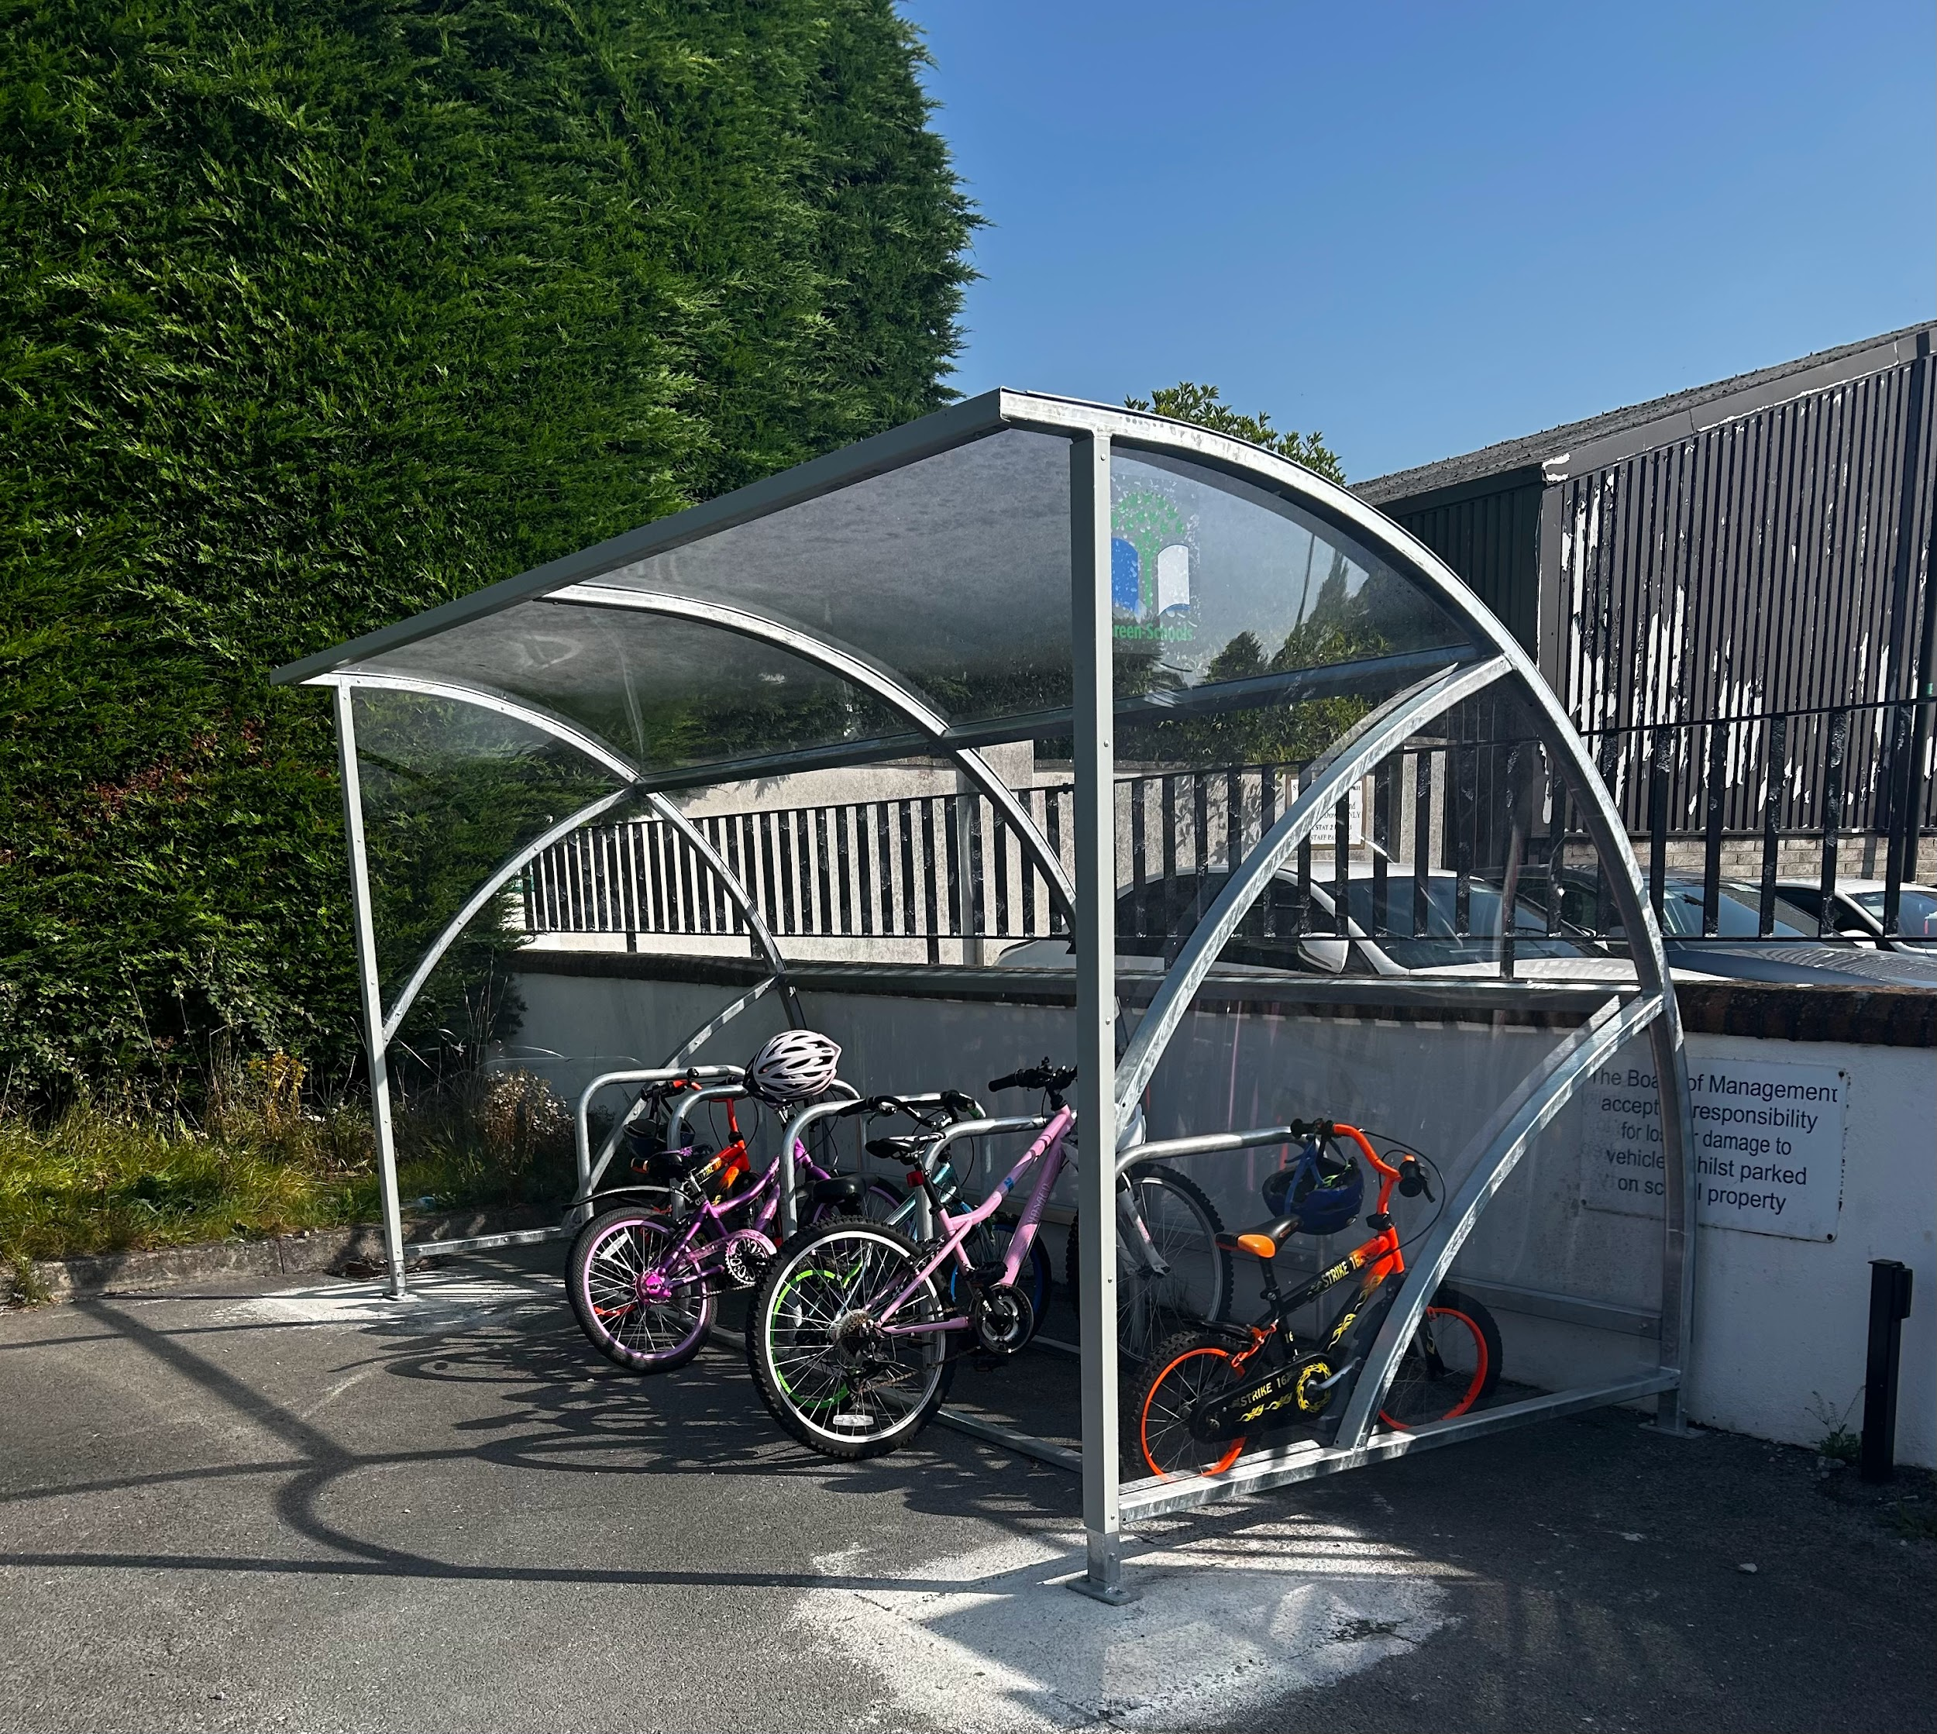
Remember Green is cool at home and at school

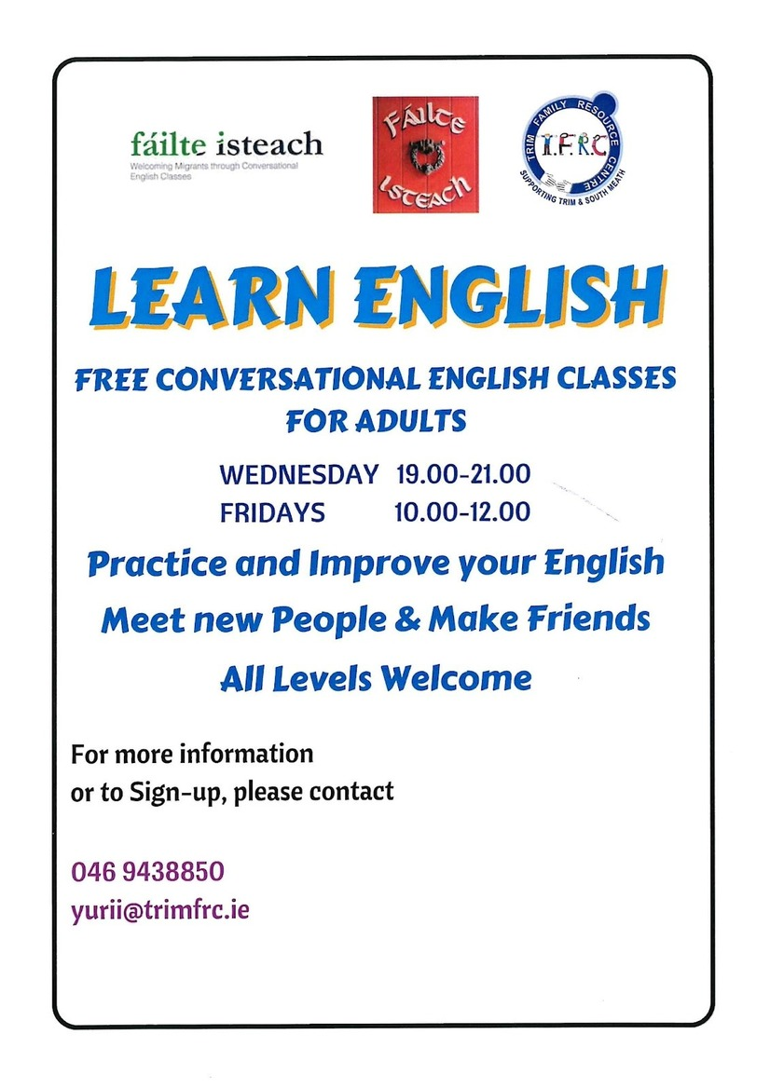
Community Notices

Boyneside Speech & Drama Classes
Focusing on improving students' confidence, pronunciation, conversation and public speaking skills will resume after school in Breathe Pilates Studio, Patrick Street, Trim on Tuesday 5th and Wednesday 6th September for children from senior infants - 6th Class.
Tel 087-2201981 or email: dorscully@gmail.com
Dorothy Scully L.L.S.M.

