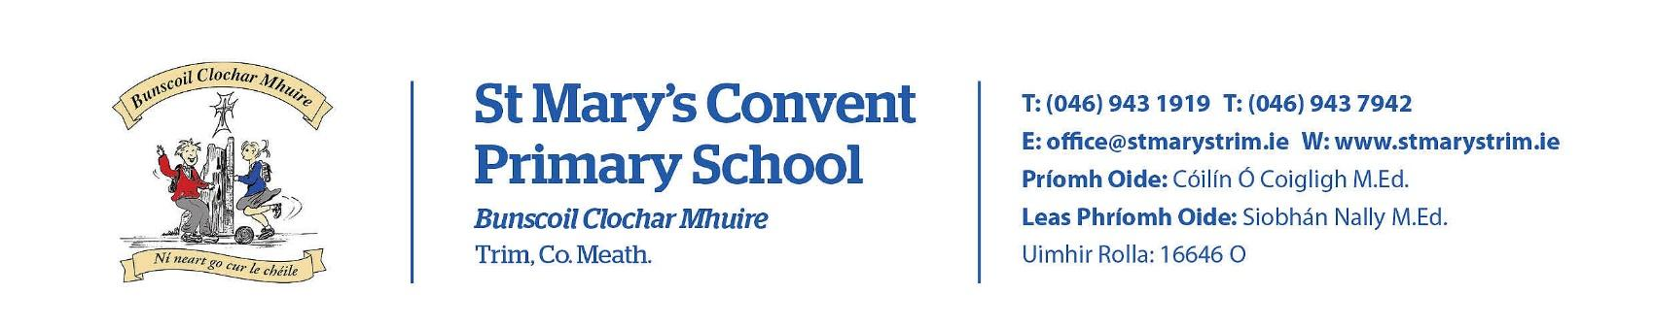
Imlitir 4

18th September 2023

A Chairde,

Friendship Week 2023
This week is Friendship Week in our school. The whole school will be focusing on the theme of Friendship through story, poetry, art, games, drama and many other activities. Thank you to all the children in Rooms 17 and 15 who participated in our Friendship Week assembly last week.
Ms. Minogue

School photographer: will be coming this Friday 22nd September. They will be taking photographs of all children. If you do not wish your child to have his/her photograph taken, please let us know. A note in the Homework Journal will suffice. Group photographs will be taken for Junior Infants and Sixth Classes only. Proofs will be available before purchase, about two weeks afterwards. Please ensure that your child is in school uniform and not tracksuit on this day(tracksuit for Junior Infants). They may bring a tracksuit to change into for PE, if this applies.

Rainbows provides peer group support for children experiencing grief and loss as a result of bereavement or parental separation. Rainbows is a listening service only. Rainbows is not a counselling service. Attending the nine week programme provides children with an opportunity to meet with other children of a similar age and loss experience. If we have sufficient numbers, the weekly programme will begin mid November. It takes place after school from 2.50pm - 3.45pm for nine weeks with two trained staff members who facilitate the sessions. Participants must be in 1st – 6th class and min. age 7 years. (There are no rainbows sessions available for Junior & Senior Infants at the present time)
Further questions or queries please contact the school co-ordinator Fiona O’Brien

Banna Ceoil: Banna Ceoil (The school Band) will take place every Tuesday in the Hall at 2:55 pm. for one hour. All pupils from 3rd class up to 6th are welcome. Registration tomorrow 19th Sept @ 2:50pm. €10 admin fee applies.

Board of Management Agreed Report
The Board met on Tuesday 12th September where the following was discussed:
- Approved changes to Child Protection policy arising from Circular 36/2023.
- Board acknowledged the quality of annual reports produced by ISLT.
- Approval of new teacher appointment.
- Hall roof leak update: Approval of funding from Emergency Works. Vote of thanks to Kevin Higgins for his assistance with the extension and this project.
- Updated Intimate Care Needs policy approved by the Board.
- Approval of sanction of AP1 and AP2 acting posts.
- Election of new Board of Management will take place in October.
Ms M Coakley

Jersey Day: Many thanks to all who contributed towards Jersey Day. A total of €631.50 was raised. Our Parents’ Association has agreed to back the same amount. That means that €1,263 will be added to our Sports Fund. Mile buiochas do ghach duine.

Sunday September 24th is Mercy Day. As a Mercy school, it is always a very special day for us.We will remember it with an assembly on Friday 22nd @ 9.20 in The Dr Eileen O Reilly Hall. Sr Paula, a past principal, will address the pupils and explain why we mark the occasion.
She will link the theme of friendship with Mercy.
Mercy Day September 24th: “Let nothing interest you but what relates to God’s glory”. This maxim is from the sayings of Venerable Catherine McAuley, founder of the Sisters of Mercy. We take this opportunity to wish the Mercy Sisters in our town a very happy feast day. We thank them for their devotion and dedication since they came to Trim in 1868.

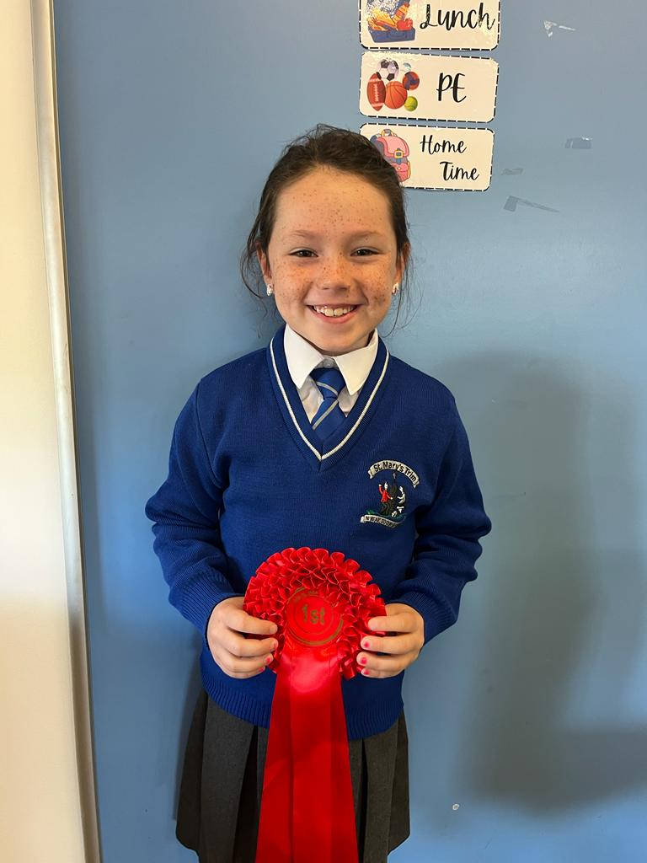
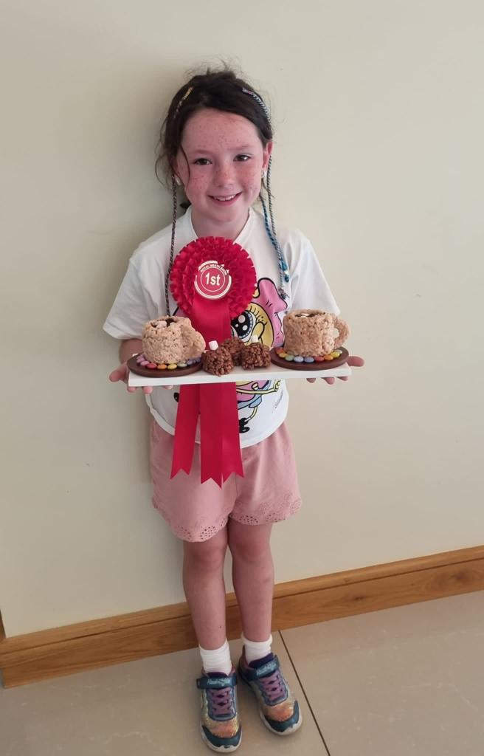
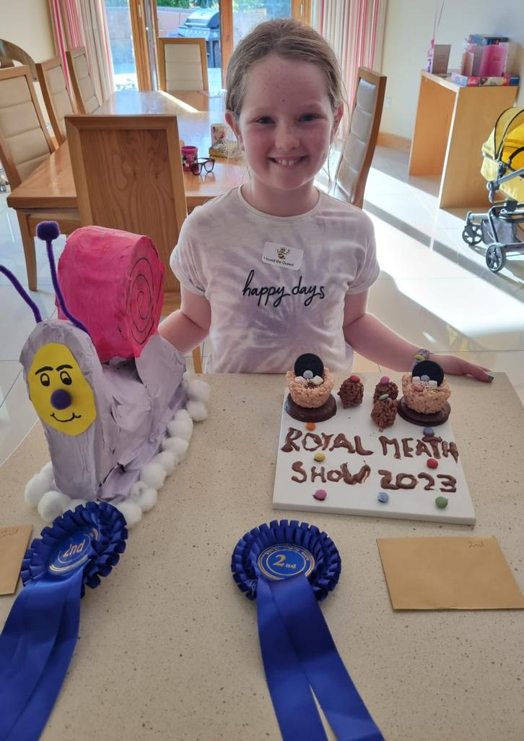
Two of our girls won prizes in the Royal Meath Show! Maith sibh!

Important Notice for Parents/Guardians of 6th Class Pupils
Boyne Community School:
Open Night: Thursday 21st September 2023 from 5pm until 7.30pm
Closing Date for First Year Enrolments 2024-25: Friday 20th October 2023 at 1pm
Link to the school's enrolment section - https://boynecs.ie/enrolment/

Parents who have barring orders or other relevant legal documents are asked to inform the school, to enable us to uphold the law at all times.

Emails/texts reminding parents/guardians about monies due to class teachers for Visual Arts etc will be sent out this week. Please ensure that we get these monies at your earliest convenience. Also, please let us know if you wish to pay by instalments or if you are contacted in error. A link to our online payment facility will be included in the email/text. The school will also facilitate a Payment Plan for families that need it. Contact Rebecca/Lara for further details.

Many thanks to all who have already made the computer contribution. There has been a positive response, all things considered. As well as providing us with a computer room assistant, this money also goes towards new software, internet charges, ink for the printers etc. If you have not already made your contribution or would like to pay in installments, please contact class teachers or Rebecca/Lara in the office. Please note that unlike the monies for Visual Arts etc. the computer contribution is voluntary.

Parents/Guardians who drop off and collect their children are asked to refrain from smoking at the school gates. Please note also that dogs are not permitted in the school grounds. Thanks.

D.T News: As part of our STEAM room initiative we have signed up for an Engineering project that is part of a country wide competition. The theme of this competition is ‘How to create something to help your community or school’. Room 18 will work in groups and come up with ideas after which they will build a model of this idea, write up documentation on what it will do etc. and we will submit it for judging. 1st classes will login in to their Google drive and will begin working on Google Docs.

Debby Walsh

Mise le meas

Cóilín Ó Coigligh P.O.

Dates to Remember

Banna (School Band) Registration 19th September for 3rd - 6th Class
Football: Wednesdays 2.50 - 3.50 for 4th-6th Class
(Camogie will start later on in the year)
Rounders: Mondays 3.00 - 4.00 for 5th & 6th Class weather permitting
Assembly Friday: Mercy Day

Green News
Community News

Nathanna na Seachtaine: Is mise…./……is ainm dom
Seanfhocal na Míosa: Tús maith, leath na hoibre (A good start is half the battle)

Green News
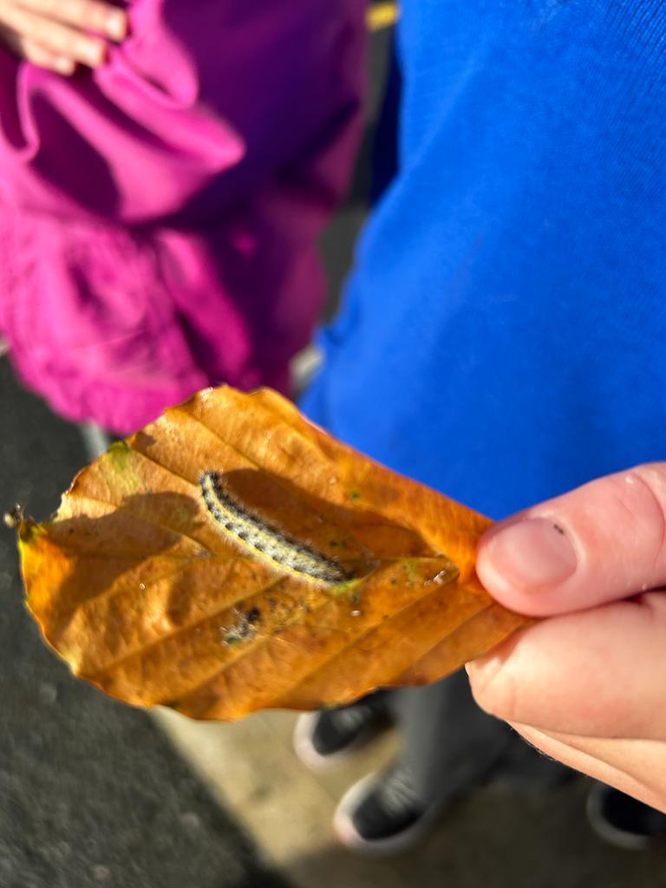
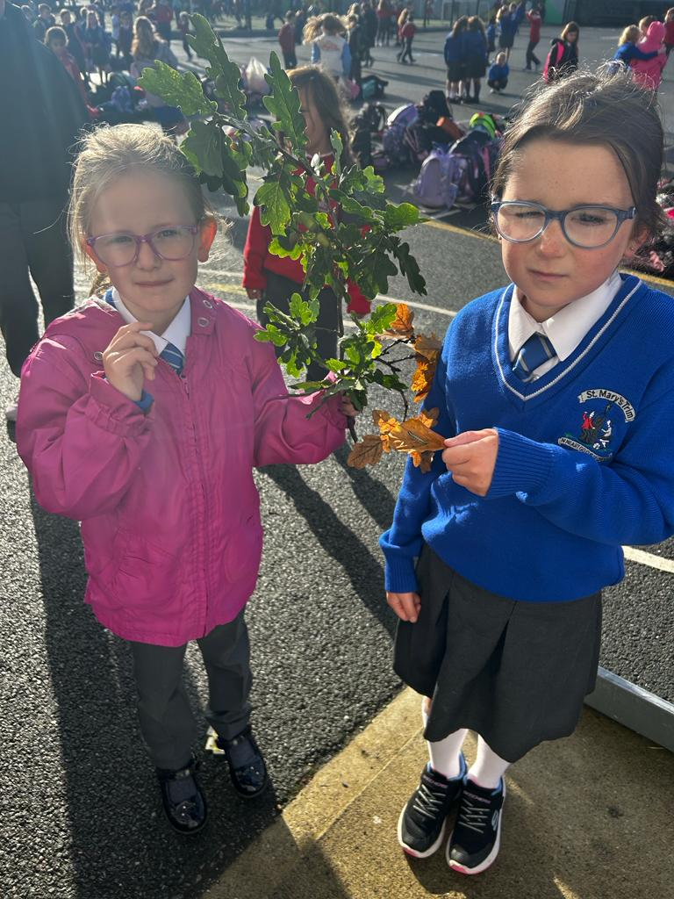

Amazing treasures of nature to be found these days

Spend some time looking around at nature this month and notice such things as blackberries, chestnuts and acorns.

We can try to recycle and reuse materials through our recycling centres or by being creative about how we can reuse items ourselves.

Two pupils set up a shop last week in their estate and used a variety of recycled items. Maith sibh a chailíní!

Our Green Flag theme is Global Citizenship - Travel. We can walk and cycle more to reduce carbon emissions and keep our air clean. WOW will start on Wednesday, September 13th Meet up at Gullivers at 8:50 am.

COW will start next week September 20th. More details about this later. We have a lovely new Bike shed so let’s put it to good use!
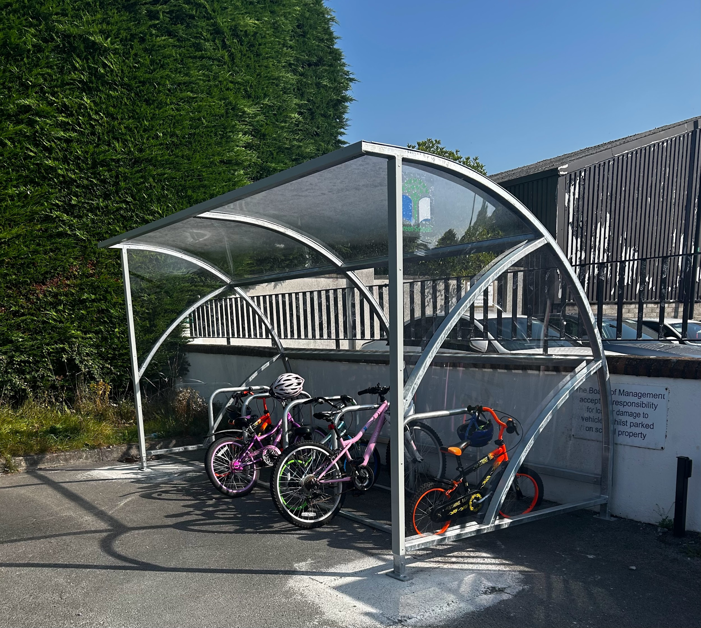
Remember Green is cool at home and at school

St Mary’s Parents’ Association
https://www.facebook.com/stmarysparentsassoc/
Please see attached notice from Parents’ Association.

Community Notices

Boyneside Speech & Drama Classes
Focusing on improving students' confidence, pronunciation, conversation and public speaking skills will resume after school in Breathe Pilates Studio, Patrick Street, Trim on Tuesday 5th and Wednesday 6th September for children from senior infants - 6th Class.
Tel 087-2201981 or email: dorscully@gmail.com
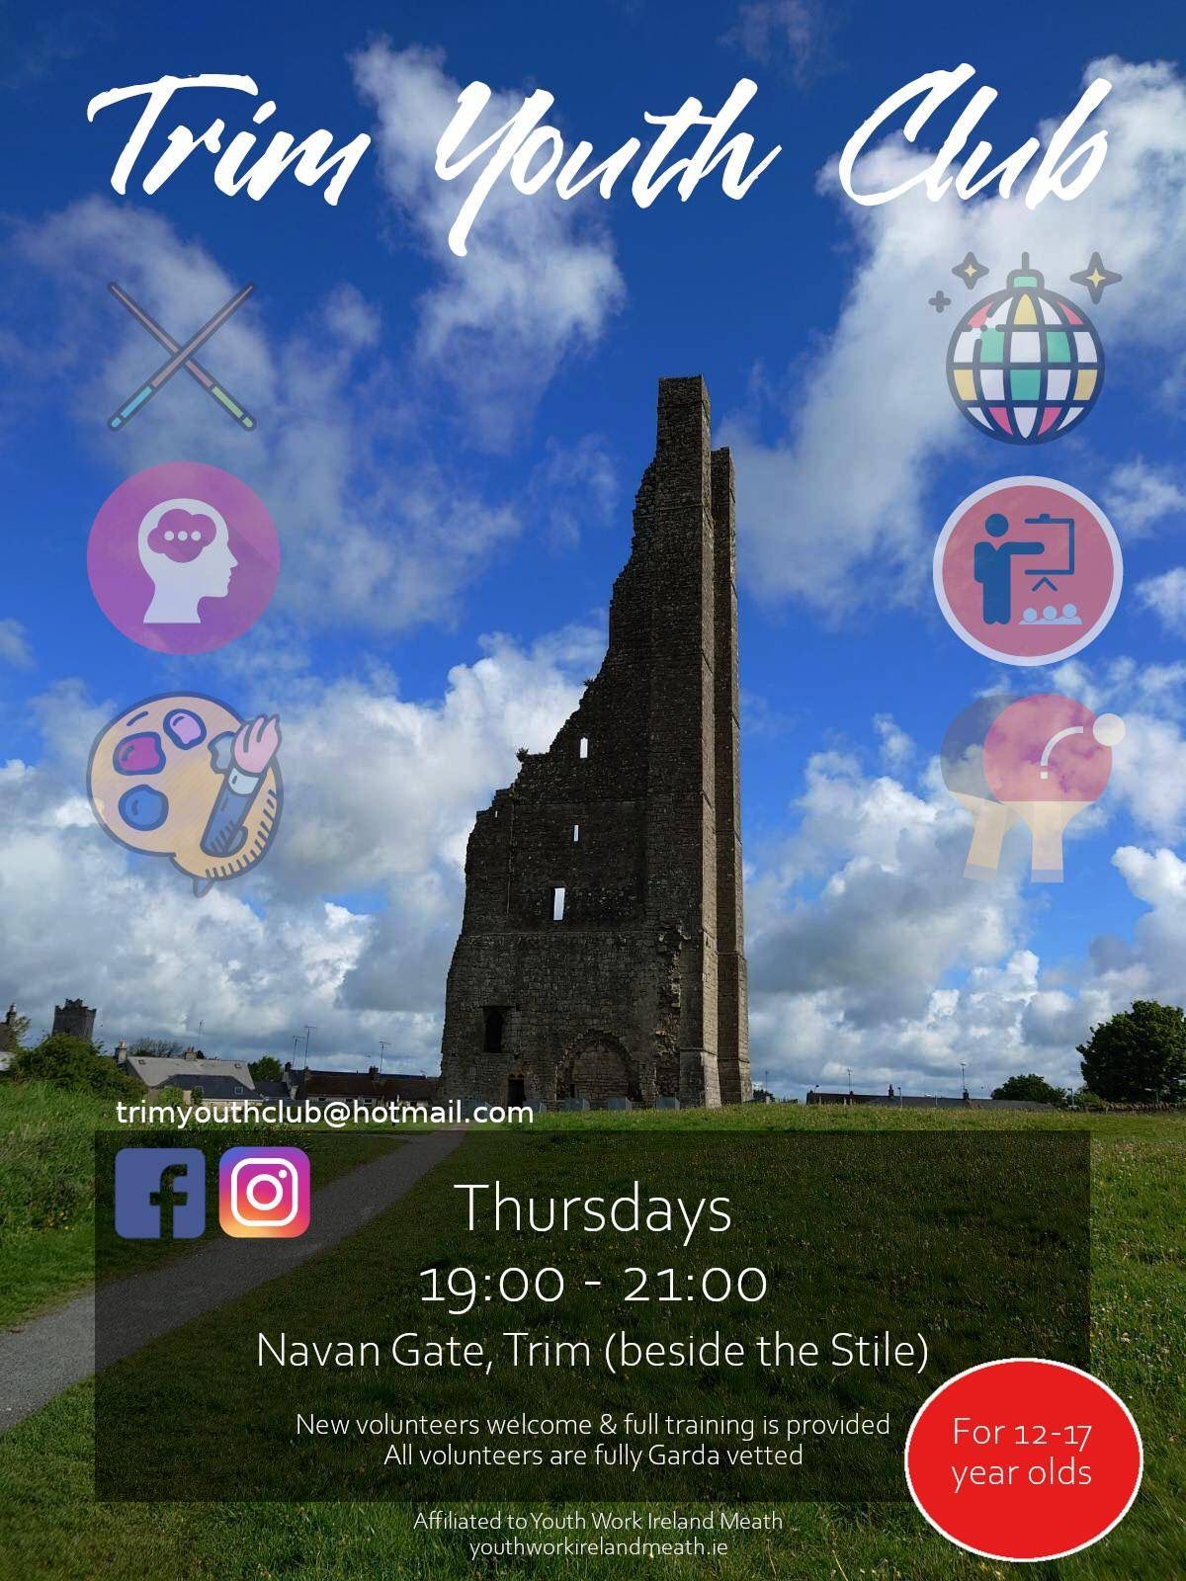
Dorothy Scully L.L.S.M.

