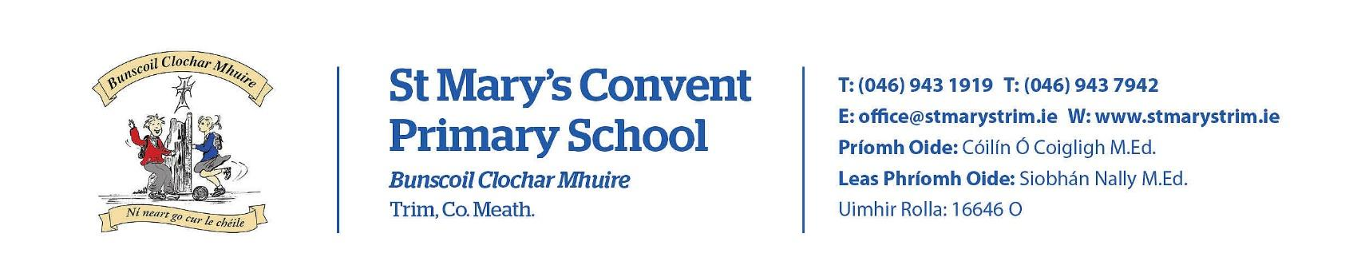
Imlitir 5

25th September 2023

A Chairde,

Our Annual Admittance Notice will be updated on our website tomorrow. It lists the various dates associated with enrolling new pupils in our school. Please see https://stmarystrim.ie/
under “Enrollments Now Open.” Completed forms will be accepted from October 1st.

Lego/Dress-up/Kitchen Donations
Junior Infant to Second Class Teachers are building on their Aistear resources for learning through play. There are two specific areas where they would appreciate donations of good quality/in good condition.
1. Lego (pieces, figures, etc.)
2. Dress-up costumes (e.g. fire fighter, nurse, doctor, etc.)
3. Old kitchens or dolls houses.
Please do not send in any other toys at this time, as we are quite restricted with storage space.
Thanking you in advance,

Confirmation this year will be on Friday January 26th @ 2.00 p.m. Communion will be on Saturday May 11th @ 2.00 p.m.

Please send notification to the school if your child is absent, not wearing the correct uniform, does not have homework completed etc. The app is the best way to do attendance and an email to the teacher/note in the journal will do for the other.. If you are not on Aladdin Connect, please contact the school for assistance.

Further questions or queries regarding Rainbows, please contact the school co-ordinator Fiona O’Brien.

Banna Ceoil: Banna Ceoil (The school Band) will take place every Tuesday in the Hall at 2:50 pm. Tomorrow’s rehearsal will be. for 40 minutes and will finish at 3:30. All pupils from 3rd class up to 6th are welcome. €10 admin fee applies.

Ukulele lessons have started again for 4th , 5th and 6th class and will continue until the end of the school year. We look forward to hearing some uplifting songs and tunes as the lessons progress.
For pupils in 5th and 6th - if you paid €50 last year and the same again this year , your child can bring a ukulele home to keep.
For those that have paid €25 this year and €50 last year , you may still avail of the purchase option if you pay another €25.
To buy a ukulele outright and pay for lessons the cost is €75 for one year only. After that the cost is €25 for lessons per year. This represents excellent value for money considering that lessons outside school hours would cost a lot more . We thank Music Generation for their generous sponsorship of this scheme. A big thank you also to Mr Fagan who gives the lessons every Monday. It's great to hear the sound of music and fun every week !
Ms McGale

D.T News: Senior Infants began their Scratch journey last week. There was great excitement when the cat began to move and talk. Scratch Junior is a free software program that works on an IPad. Students from 2nd to 5th will continue to revise all skills learnt last year in both Google Docs and Google Slides. We will also work on collaborative documents which is a great lesson in itself … no more deleting or changing slides that dont belong to you!

Debby Walsh

Mise le meas

Cóilín Ó Coigligh P.O.

Dates to Remember

Banna (School Band) Rehearsal for 3rd - 6th Class 2:50 -3:30pm
Football: Wednesdays 2.50 - 3.50 for 4th-6th Class
(Camogie will start later on in the year)
Rounders: Mondays 3.00 - 4.00 for 5th & 6th Class weather permitting
Assembly Room 18-Be Active

Green News
Community News

Nathanna na Seachtaine: Ní do lámha!/Nígí bhúr lámha!
Seanfhocal na Míosa: Tús maith, leath na hoibre (A good start is half the battle)

Green News

Our Green Flag theme is Global Citizenship - Travel. We need to link that to the Global goals. Let’s walk, cycle and scoot more to reduce carbon emissions and keep our air clean. Unfortunately the weather has made it challenging to get our WOW and COW campaigns started. WOW will resume on Wednesday if it is dry. Meet up at Gullivers at 8:50 am.

We have a lovely new Bike shed so let’s put it to good use when the weather picks up and it is safer to cycle.
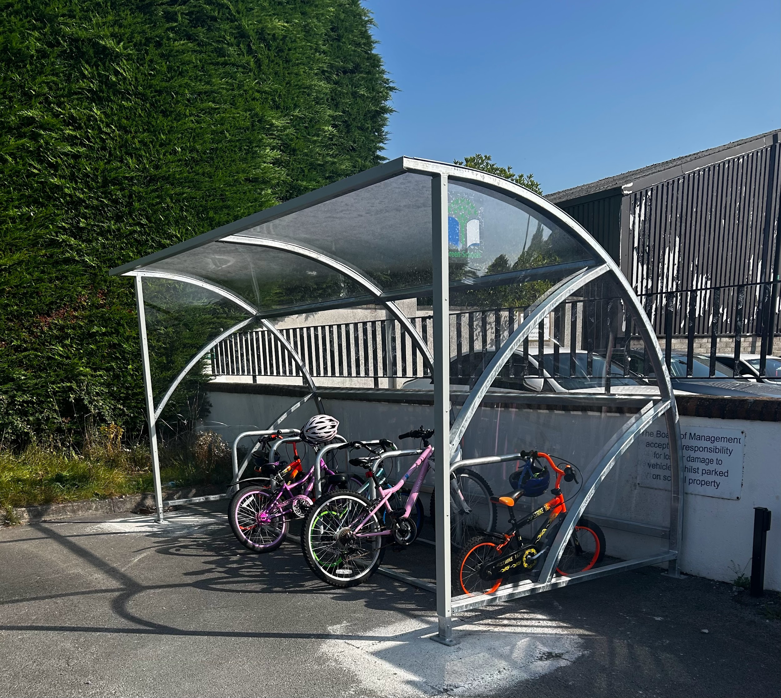

Remember Green is cool at home and at school

St Mary’s Parents’ Association
https://www.facebook.com/stmarysparentsassoc/
Reminder: Parents Asssociation AGM, Tuesday 26th of September at 8pm in school canteen. Please come along and see how you can help the Parents Association have a great year supporting our school and children.
email: pa@stmarystrim.ie

Community Notices
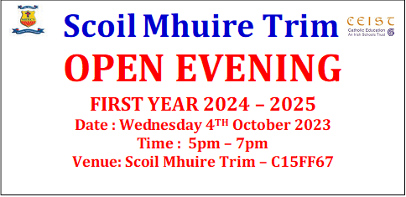

Please see the Trim Family Resource Centre newsletter attached. This newsletter highlights the programmes and events that will be running over the Autumn and Spring months.

